**A Internship**

ON

**“FRONTEND WEB DEVELOPMENT”**

# OF

**TE (AI &DS Engineering)**

**Academic Year: 2022-2023**

SUBMITTED BY

**Tejas Sadashiv Sawant**

**Roll No.: T1411065**

GUIDED BY

**Prof. Dikshenrda Sarpate**



**Department of AI & DS Engineering**

**Zeal Education Society’s**

**Zeal College of Engineering & Research Narhe, Pune-411041**

**Zeal College Of Engineering & Research, Narhe, Pune**

**2022-2023**

**CERTIFICATE**



This is to certify that the internship report entitled “**FRONTEND WEB DEVELOPMENT**” has been carried out by **Tejas Sadashiv Sawant (T1411065)** under my guidance in partial fulfilment of the engineering of **AI & DS Engineering** of **Zeal College Of Engineering & Research, Narhe, Pune** during Academic year **2022-2023.** To the best of knowledge and belief this work has not seen submitted elsewhere for the award of any other Engineering.

|  |  |
| --- | --- |
| **Prof. Dikshendra Sarpate** | **Prof. Dikshendra Sarpate** |
| **Guide** | **H.O.D** |
| **AI & DS Engineering** | **AI & DS Engineering** |
| **Department** | **Department** |

**Place: Pune Date:**

**INTERNSHIP OFFER LETTER**

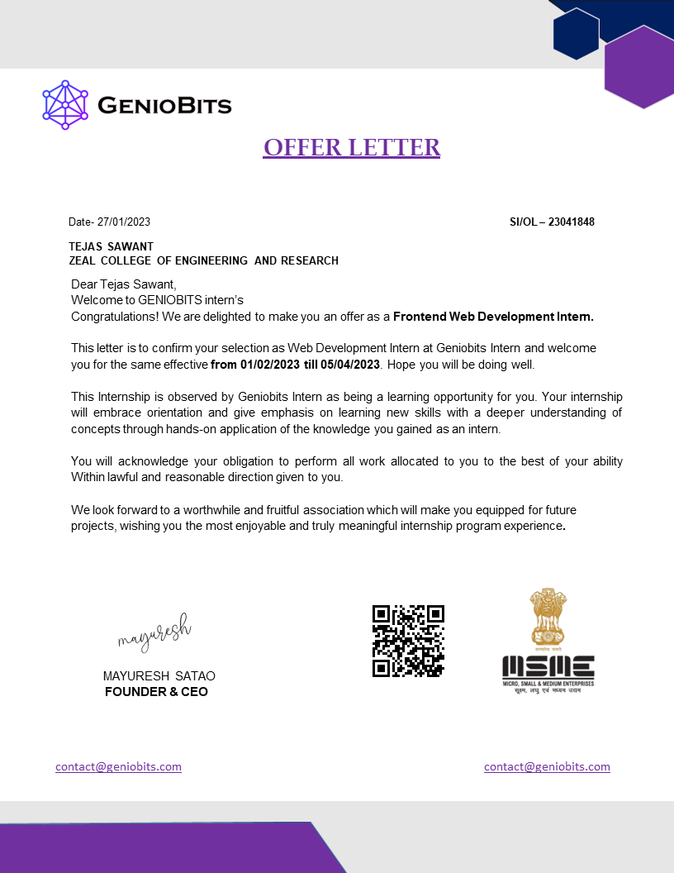

**INTERNSHIP CERTIFICATE**

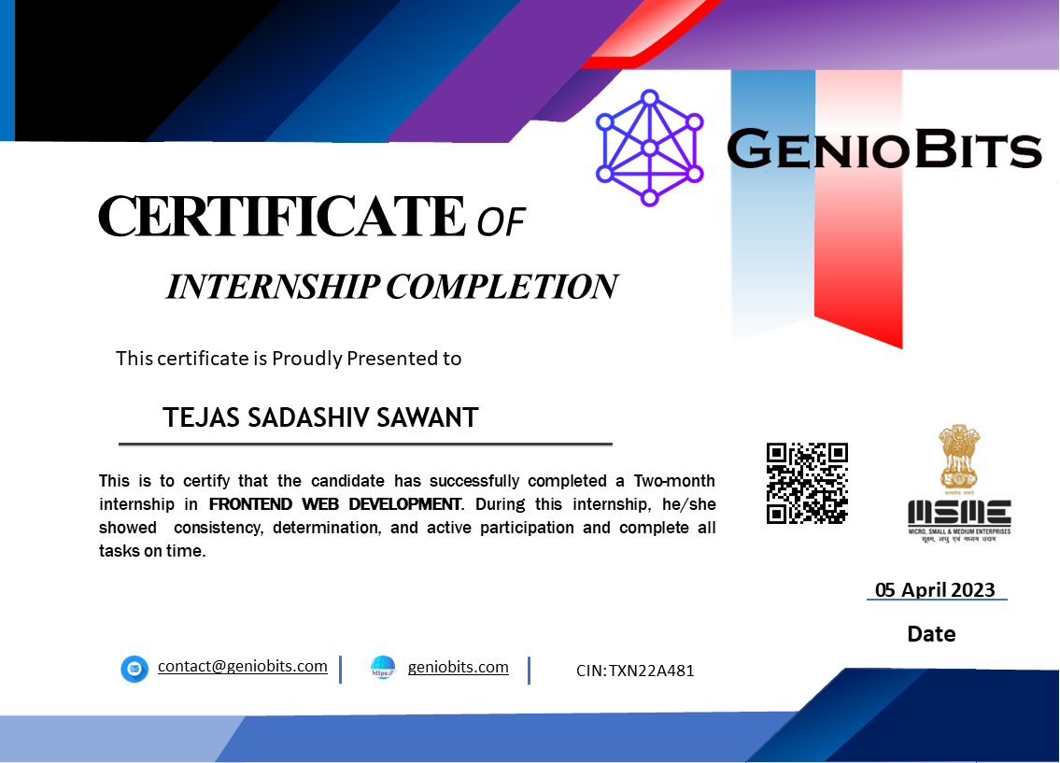

**Industry Details :**

* **Name of the Industry** – GENIOBITS PRIVATE LIMITED.
* **Address of the Industry** – GENIOBITS PRIVATE LIMITED, Gate No 163, Flat No  A-402 Nisarg, Hundekari Wasti, Phursungi, Pune Mharashtra, India 412308
* **Website Address of the Industry** - https://geniobits.com/
* **Founder & CEO –** Mr. Mayuresh Satao

**About Industry:**

Geniobits does more than just developing software. We help our clients solve their business challenges through digital transformation. Geniobits brings a wide range of digital transformation solutions: web, android, iOS, desktop applications, IoT, proactive maintenance and support. We will design you  
solutions in close cooperation with your team members. To meet your needs and expectations,  
dedicated teams and tribes are formed. We are tightly aligned with your business.

**Industry IT Services:**

* [Product Design](https://geniobits.com/service/product-design/)
* [Cyber Security](https://geniobits.com/service/cyber-security/)
* [Data Research](https://geniobits.com/service/data-research/)
* [Cloud Storage](https://geniobits.com/service/cloud-storage/)
* [Web Development](https://geniobits.com/service/web-development/)
* [App Development](https://geniobits.com/service/app-development/)
* [Data Science](https://geniobits.com/service/data-science/)
* [Marketing](https://geniobits.com/service/marketing/)
* [Algo Trading](https://geniobits.com/service/algo-trading/)

**Details of the External Mentor (Supervisor) from Industry:**

* **Name** – Imran Kabir
* **Contact Number** - +91 66926 28467
* **Email ID** – [imran.kabir@gmail.com](mailto:imran.kabir@gmail.com)

**LIST OF CONTENT**

|  |  |  |
| --- | --- | --- |
| **Sr. No.** | **Contents** | **Page No.** |
|  | INTRODUCTION | 8 |
|  | PROBLEM STATEMENT | 10 |
|  | MOTIVATION | 13 |
|  | METHODOLOGICAL DETAILS | 14 |
|  | SOFTWARE REQUIREMENTS SPECIFICATIONS | 18 |
|  | RESULT | 19 |
|  | ATTENDENCE RECORD | 31 |
|  | ACKNOWLDEGEMENT | 32 |
|  | CONCLUSION | 33 |
|  | REFERENCES | 34 |

Chapter 1 INTRODUCTION

A web development internship is an opportunity for individuals interested in learning how to build websites and web applications to gain practical, hands-on experience working on real-world projects. It typically involves working closely with experienced web developers, designers, and other professionals in a team environment to build, test, and deploy web-based solutions.

During a web development internship, interns may be responsible for a range of tasks, including designing user interfaces, writing code in various programming languages, testing and debugging web applications, and collaborating with team members to ensure project goals are met. The specific responsibilities and expectations of the internship may vary depending on the organization and the specific internship program.

Overall, a web development internship is a valuable opportunity for individuals looking to gain experience in the field, build their skills, and make connections within the industry. It can be a stepping stone to a career in web development or related fields, and it can also help interns to identify areas of interest and specialize their skills.

**About the Company**

[GENIOBITS PRIVATE LIMITED](https://www.insiderbiz.in/company/GENIOBITS-PRIVATE-LIMITED)is a Private Company, Which CIN Number isU72900PN2019PTC185417 , was incorporated 3 Year(s) 9 Month(s) 26 Day(s) ago on dated 12-Jul-2019 . GENIOBITS PRIVATE LIMITED is classified as Non-govt company and is registered at Registrar of Companies located in ROC-PUNE. As regarding the financial status on the time of registration of GENIOBITS PRIVATE LIMITED Company its authorized share capital is Rs. 500000 and its paid up capital is Rs. 135000. As Per Registration of Company, It involves under in Business Activity Class / Subclass Code 72900, Main Activity of the said Company GENIOBITS PRIVATE LIMITED is : , Other computer related activities [for example maintenance of websites of other firms/ creation of multimedia presentations for other firms etc.], It Comes Under Division COMPUTER AND RELATED ACTIVITIES and this come under scetion REAL ESTATE, RENTING AND BUSINESS ACTIVITIES.  
 The registration number of this company is 185417 .Its Email address is msatao78@gmail.com and its registered address is where Company is actual registered : GAT NO.163 FLAT NO.A-402 NISARG, HUNDEKARI WASTI PHURSUNGI PUNE Pune MH 412308 IN. For any Query You can reach this company by email address or Postal address.

* 1. **Vision**
* We act as trusted advisors.
* When our customers succeed, we succeed.
* We innovate together.
* Everyone deserves equal opportunities.

**1.2 Mission**

* To enable people and businesses throughout the world to realize their full potential.
* Accelerate business and simplify life for companies and people around the world.
  1. **Goals**
* Standardize and codify key software project concepts and terminology.
* Ensure business goals and objectives are considered at all stages of a project.
* Develop an accurate and flexible model describing key project activities.
* Identify and leverage accurate insights into software project success and failure rates and reasons.
* Identify and encourage best practices which are appropriate for a particular project.
* Encourage a spirit of openness, transparency, integrity, trust, and continuous learning.
* Build and nurture a global community that shares our vision and mission.

Chapter 2

**PROBLEM STATEMENT**

**2.1 College Website**

Problem Statement: Many colleges and universities struggle with outdated and ineffective websites, which can make it difficult for students, faculty, and staff to access the information they need. Current college websites often lack important features, such as easy navigation, personalized content, and mobile responsiveness, making it challenging for users to find the information they need in a timely manner.

The problem with the current college websites is that they are often cluttered with too much information and not enough focus on the most important details. Additionally, the navigation and user interface design can be confusing and overwhelming for users, leading to frustration and a poor user experience. Furthermore, many college websites are not optimized for mobile devices, which is becoming increasingly important as more and more people use their smartphones and tablets to access information online.

Therefore, there is a need for a modern and effective college website that offers easy navigation, personalized content, and mobile responsiveness. A college website that solves these problems would be highly appreciated by students, faculty, and staff, making it easier for them to find the information they need quickly and efficiently.

**2.2 Music Player Website**

Many people enjoy listening to music online, but finding a reliable and user-friendly music player website can be challenging. Existing music player websites often have limited features, poor user interface design, and are not optimized for different devices, making it difficult for users to enjoy their favorite songs seamlessly.

The problem with the current music player websites is that they lack advanced features like music recommendations, user customization, and social sharing options. Additionally, the user interface design is often cluttered, with too many options and not enough focus on the core features. Moreover, the websites are not optimized for different devices, making it challenging for users to enjoy their favorite music seamlessly across all platforms.

Therefore, there is a need for a music player website that offers a user-friendly interface, advanced features, and is optimized for different devices. A music player website that solves these problems would be highly appreciated by music lovers, making it easier for them to listen to their favorite songs anytime, anywhere.

**2.3 Tic Tac Toe Game Website**

Tic-tac-toe is a classic and popular game that can be enjoyed by people of all ages. However, playing the game can be challenging when there is no partner available, or when players are in different locations. Traditional methods of playing tic-tac-toe, such as on paper or on a physical board, are not always convenient, particularly in today's digital age.

This project aims to address these challenges by developing a user-friendly and engaging tic-tac-toe game website that enables players to enjoy the game from anywhere in the world. The website will offer a range of game modes, including single-player against an AI opponent, multiplayer with friends, and competitive play with other online users. The website will also offer a user-friendly interface that guides players through the game-playing process, helping them to enjoy the game in a fun and engaging manner.

Chapter 3

**MOTIVATION**

**3.1 College Website**

A well-designed college website can provide a wealth of benefits for students, faculty, staff, and the college community as a whole. It can serve as a central hub for information, resources, and communication, making it easier for users to access what they need and stay connected with each other. A modern and effective college website can offer personalized content, making it easier for users to find the information they need quickly and efficiently. By utilizing user data and analytics, a college website can tailor its content to individual users, providing a more engaging and personalized user experience.

Moreover, a college website can enhance the overall college experience for students, providing them with a comprehensive resource for academic and extracurricular activities. It can offer features such as course schedules, campus maps, social events, and student organizations, making it easier for students to get involved and feel connected to their college community. For faculty and staff, a college website can offer important resources and tools to support their work, such as employee directories, departmental information, and professional development opportunities.

Finally, a well-designed college website can help the college to reach a wider audience and promote its brand. A website that is optimized for search engines and social media can attract potential students and stakeholders, helping to increase enrollment and improve the college's reputation. Overall, a well-designed college website can provide a wide range of benefits for students, faculty, staff, and the college community, making it an essential tool for any college or university.

**3.2 Music Player Website**

Music has always been a part of human life and culture. It has the power to evoke emotions, express thoughts, and bring people together. With the advancement of technology, music has become more accessible than ever, and people can now listen to their favorite songs from anywhere, anytime.

However, the existing music player websites often lack advanced features and are not user-friendly, making it difficult for users to enjoy their music seamlessly. This can be frustrating for music lovers, who want to have a seamless and personalized music listening experience. A well-designed music player website can solve these problems and offer a better user experience. It can provide advanced features like personalized playlists, music recommendations, social sharing options, and seamless integration across different devices. With a music player website, users can enjoy their favorite songs seamlessly, customize their music listening experience, and discover new music effortlessly.

Furthermore, a music player website can help promote new and emerging artists, making it easier for them to reach a wider audience. By providing a platform for artists to showcase their music, a music player website can contribute to the growth and development of the music industry. Overall, a well-designed music player website can be a valuable resource for music lovers, artists, and the music industry as a whole

**3.3 Tic-Tac-Toe Game Website**

Tic-tac-toe is a popular game that has been played for centuries. It is a simple yet challenging game that requires strategic thinking and planning. With the advancement of technology, the game has evolved into an online game, providing a new way for people to enjoy the game.

A well-designed tic-tac-toe game website can offer a better user experience, providing users with an easy-to-use interface and advanced features. It can provide users with the ability to play the game against other players from around the world, adding a competitive element to the game. It can also offer different game modes, such as single-player, two-player, or tournament modes, making the game more exciting and engaging.

Furthermore, a tic-tac-toe game website can help improve critical thinking and problem-solving skills. Playing the game requires strategic thinking and planning, which can be helpful in other areas of life. By providing an online platform to play the game, a tic-tac-toe game website can help people to develop these skills in a fun and engaging way.

Finally, a tic-tac-toe game website can be a valuable resource for educators, providing a fun way for students to learn and practice critical thinking and problem-solving skills. By incorporating the game into their lesson plans, educators can make learning more engaging and enjoyable. Overall, a well-designed tic-tac-toe game website can be a valuable resource for people of all ages, offering a fun and engaging way to improve critical thinking and problem-solving skills.

Chapter 4

**METODLOGICAL DETAILS**

**4.1 What is Web Development?**

Web development is the process of creating websites and web applications that run on the internet. It involves a range of skills, including designing, coding, programming, testing, and maintaining websites.

The main components of web development include client-side coding, server-side coding, and database management. Client-side coding involves creating the user interface and visual design of the website, usually using HTML, CSS, and JavaScript. Server-side coding involves creating the server-side scripts that interact with the server and process user requests, usually using languages such as PHP, Python, or Ruby. Database management involves designing and maintaining the databases that store website data and information.

Web development can range from simple static websites to complex web applications that involve advanced functionality and integration with other systems. It plays a crucial role in modern business and society, providing a platform for e-commerce, social media, communication, and information sharing.

**4.2 Tools and Technologies used**

**4.2.1 HTML**

HTML stands for Hyper Text Markup Language. It is the standard markup language used to create web pages and web applications. HTML provides the structure and content of a web page, and it allows developers to format and style the content using CSS (Cascading Style Sheets) and add interactivity with JavaScript. HTML uses tags to define various elements such as headings, paragraphs, images, links, forms, and more, and these tags are interpreted by web browsers to render the web page.

**4.2.2 CSS**

CSS stands for Cascading Style Sheets. It is a style sheet language used for describing the presentation and layout of HTML or XML documents. CSS allows developers to control the appearance of web pages by specifying how HTML elements should be displayed, including the layout, colors, fonts, and other visual effects. With CSS, developers can separate the presentation of a web page from its content, making it easier to maintain and update the design of a website. CSS also allows developers to create responsive web pages that adapt to different screen sizes and devices.

**4.2.3 JavaScript**

JavaScript is a high-level programming language that is commonly used to create interactive and dynamic effects within web browsers. It is primarily used for creating client-side behavior of web pages, such as validating forms, creating animations, and building interactive features like menus and image sliders. JavaScript can also be used for server-side programming through platforms like Node.js. It was first developed in 1995 by Brendan Eich and has since become one of the most popular programming languages for web development.

**4.2.4 Bootstrap**

Bootstrap is a free and open-source CSS framework that provides a collection of pre-built design components, such as forms, buttons, typography, navigation, and other interface elements. It was originally developed by Twitter and is now maintained by a group of developers as an open-source project. Bootstrap is used to create responsive and mobile-first web pages and applications, which means that they can be easily viewed and interacted with on different screen sizes, from desktop computers to mobile devices. Bootstrap also includes JavaScript plugins, such as modals, dropdowns, and carousels, to enhance the functionality of the user interface.

**4.2.5 Java Server Page**

React is an open-source JavaScript library used for building user interfaces or UI components. It was developed by Facebook and it allows developers to create reusable UI components and manage the state of those components. React follows a declarative approach to programming, where developers only need to specify what the UI should look like and React takes care of updating the UI automatically when the state changes. React also uses a virtual DOM, which allows it to update the UI efficiently by only rendering the components that have changed.

**4.2.6 DBMS**

DBMS stands for Database Management System. It is a software system used to manage and organize data in a database. A DBMS provides various features like data storage, data retrieval, data security, and user management. It allows multiple users to access and manipulate the data in a shared database. DBMSs are widely used in various applications such as banking, healthcare, education, and e-commerce, where large amounts of data need to be stored and processed. Examples of popular DBMSs include Oracle, MySQL, Microsoft SQL Server, PostgreSQL, and MongoDB.

**4.2.7 React**

Java Server Pages (JSP) is a technology used for creating web pages that dynamically generate HTML, XML, or other types of documents in response to a web client request. JSP is a technology that enables developers to embed server-side code into their HTML pages, allowing for the creation of dynamic web content that can change based on user input or other factors. It is a part of the Java Enterprise Edition platform and can be used in conjunction with Java servlets to create robust and scalable web applications. With JSP, developers can create web pages that interact with databases, handle form data, and display dynamic content based on user preferences.

**4.2.8 JQuery**

jQuery is a fast, small, and feature-rich JavaScript library designed to simplify HTML document traversal and manipulation, as well as event handling, animation, and Ajax interactions for web development. It is open source and cross-platform, and it allows developers to write less code while achieving the same or more functionality. jQuery is commonly used in web development for creating dynamic and interactive websites and web applications.

**4.2.9 PHP**

PHP (Hypertext Preprocessor) is a server-side scripting language used primarily for web development. It is a popular programming language for creating dynamic web pages and web applications. PHP code is executed on the server and generates HTML output that can be sent to the client-side for rendering in a web browser. PHP can be embedded into HTML code, and can also interact with databases to store and retrieve information. It is an open-source language and is widely used by web developers around the world.

**4.2.10 Java**

Java is a general-purpose programming language that is class-based, object-oriented, and designed to have as few implementation dependencies as possible. It is intended to let application developers write once, run anywhere (WORA), meaning that compiled Java code can run on all platforms that support Java without the need for recompilation. Java applications are typically compiled to bytecode that can run on any Java virtual machine (JVM) regardless of the underlying computer architecture. Java is widely used for developing mobile applications, desktop applications, web applications, and games.

**4.2.11 VS Code**

Visual Studio Code (VS Code) is a free and open-source code editor developed by Microsoft. It provides support for various programming languages, including HTML, CSS, JavaScript, TypeScript, Python, and more. VS Code is available for Windows, macOS, and Linux operating systems and is widely used by developers for web development, desktop development, and other programming tasks. It features a rich set of features such as debugging, syntax highlighting, auto-completion, and code refactoring, and also supports various extensions that enhance its functionality

**4.2.12 XAMPP**

XAMPP is a free, open-source web server software package developed by Apache Friends. It includes Apache HTTP Server, MariaDB database, and interpreters for the PHP and Perl programming languages. XAMPP is used to set up a local web server environment on a computer for web development and testing purposes. It is available for Windows, macOS, and Linux operating systems.

**4.2.13 Tomcat**

Apache Tomcat is an open-source web server and servlet container developed by the Apache Software Foundation. It provides a pure Java HTTP web server environment to run Java code. It also supports the JavaServer Pages (JSP) and Java Servlet technologies, allowing the deployment of web applications based on Java technologies. Tomcat is widely used to deploy web applications and is supported by various operating systems, including Windows, Linux, and macOS.

**4.2.14 MYSQL**

MySQL Workbench is a visual tool for designing, developing, and administering MySQL databases. It provides a graphical interface for performing tasks such as creating and managing database schemas, running SQL queries, and configuring server settings. MySQL Workbench supports database modeling, SQL development, and database administration, making it a comprehensive tool for working with MySQL databases.

Chapter 5

**SOFTWARE REQUIREMENT SPECIFICAION**

**Operating System:** Windows7, Windows 10, Windows 11, Linux, MacOS.

**Language:** HTML, CSS, JavaScript, jQuery, MySQL, React, Java Server Page.

**Browser:** Any of Mozilla, Opera, Chrome etc.

Chapter 6

**RESULTS**

**6.1 College Website**

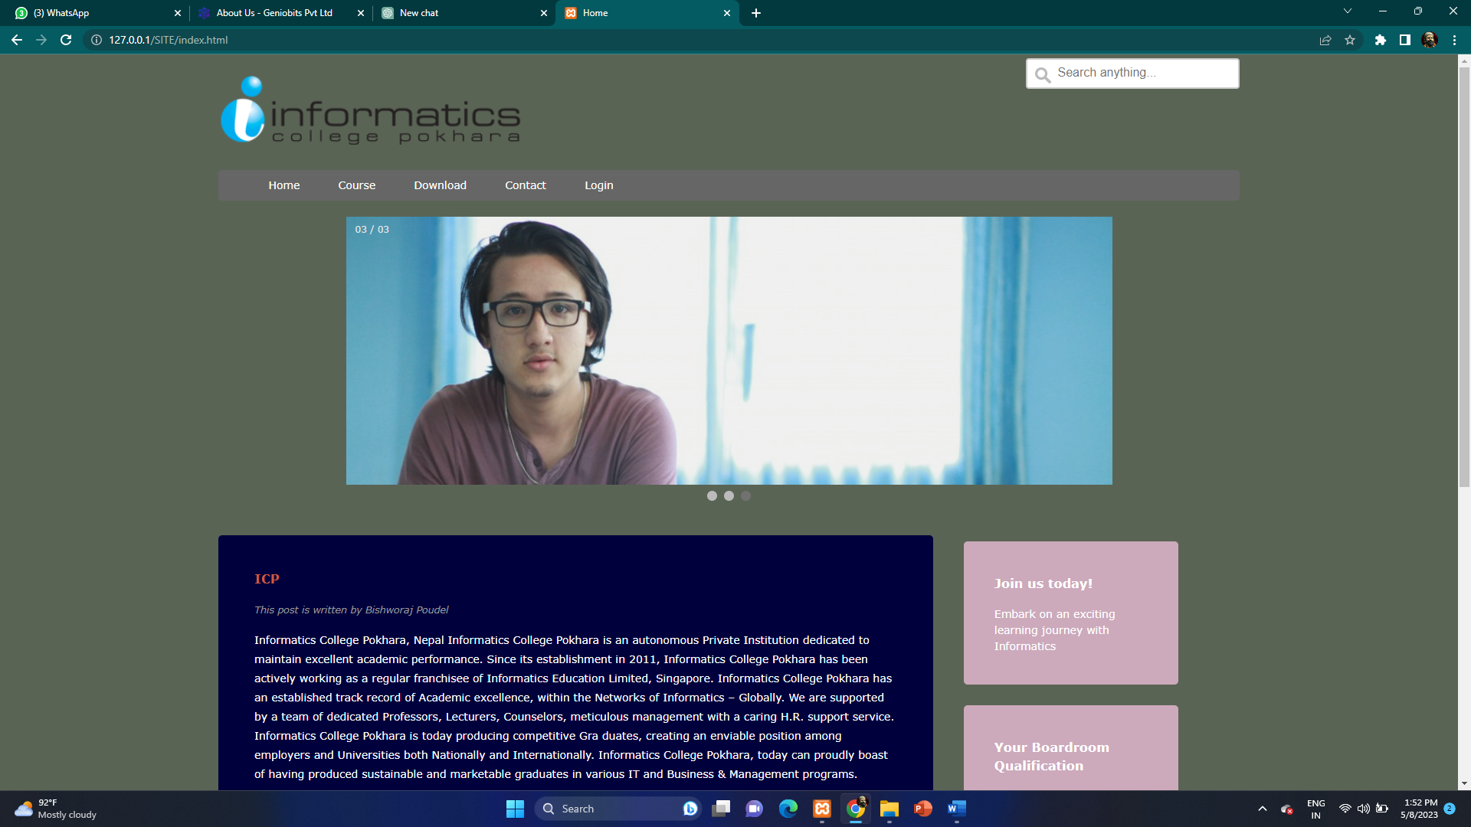

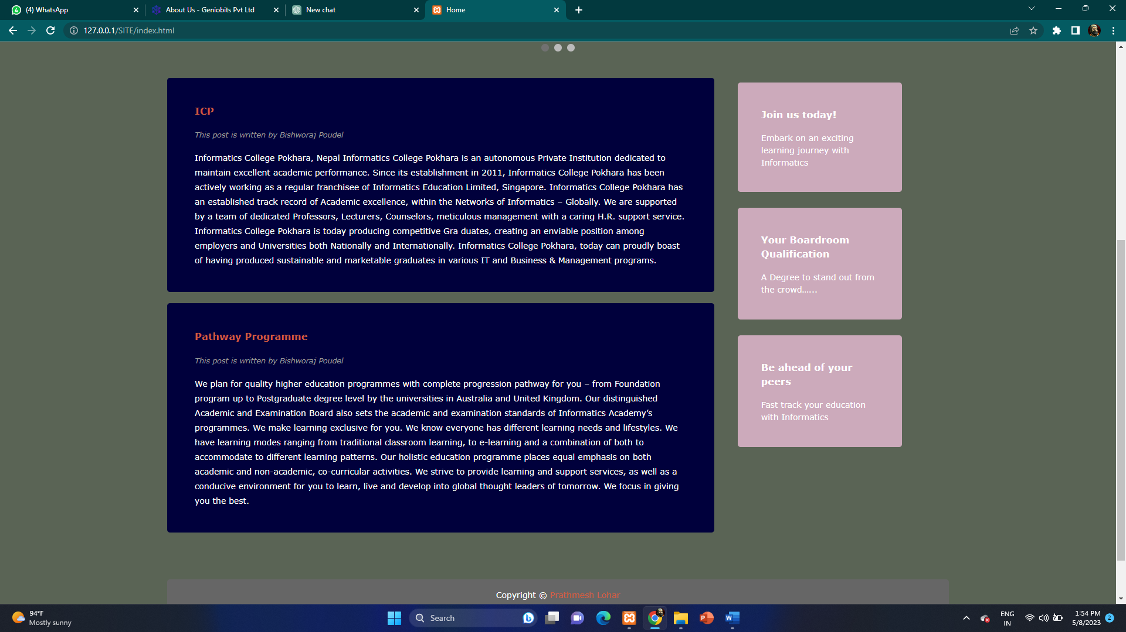

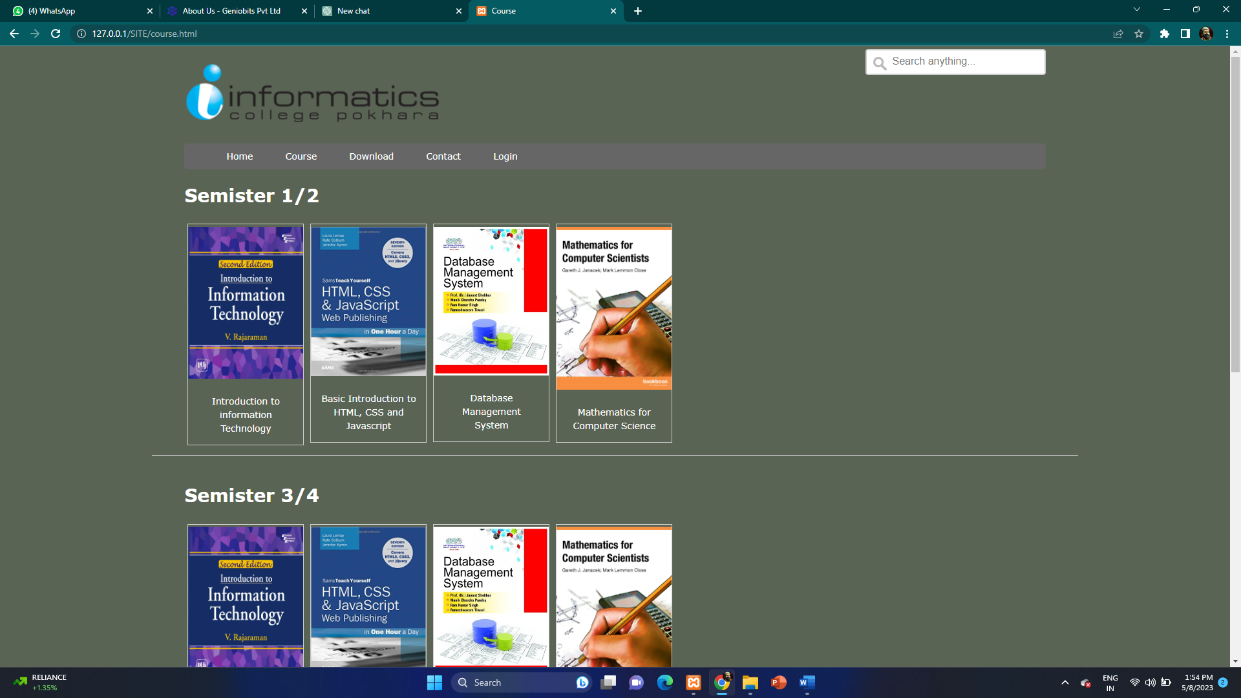



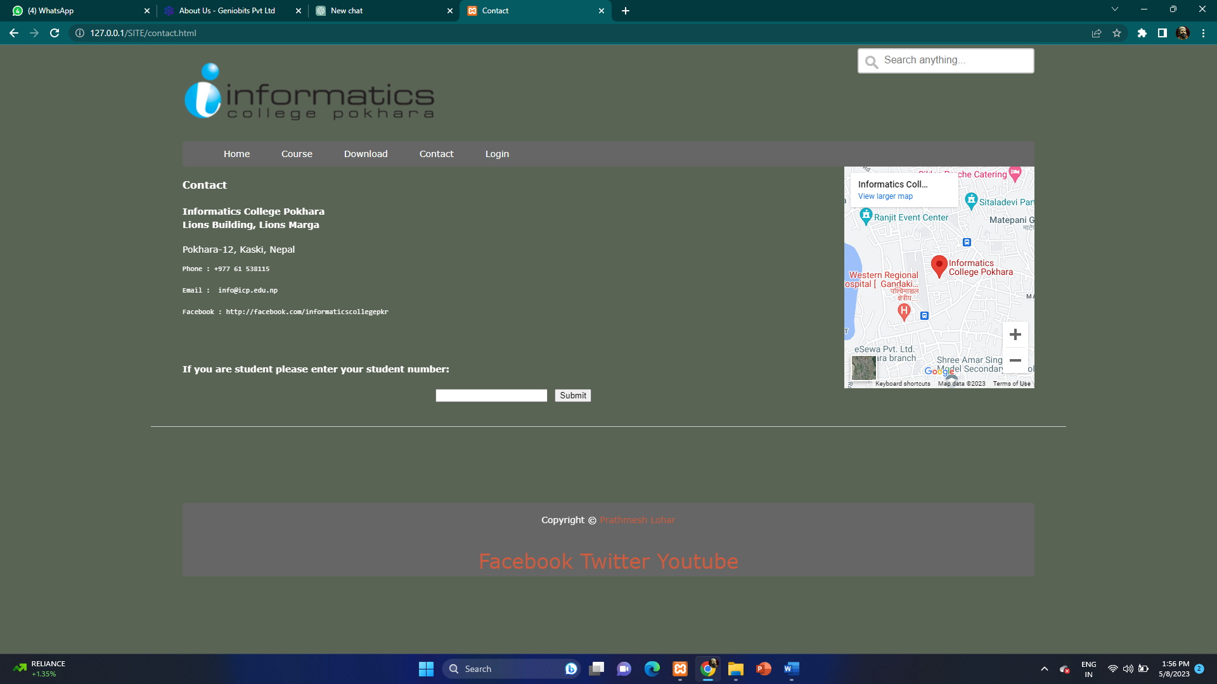

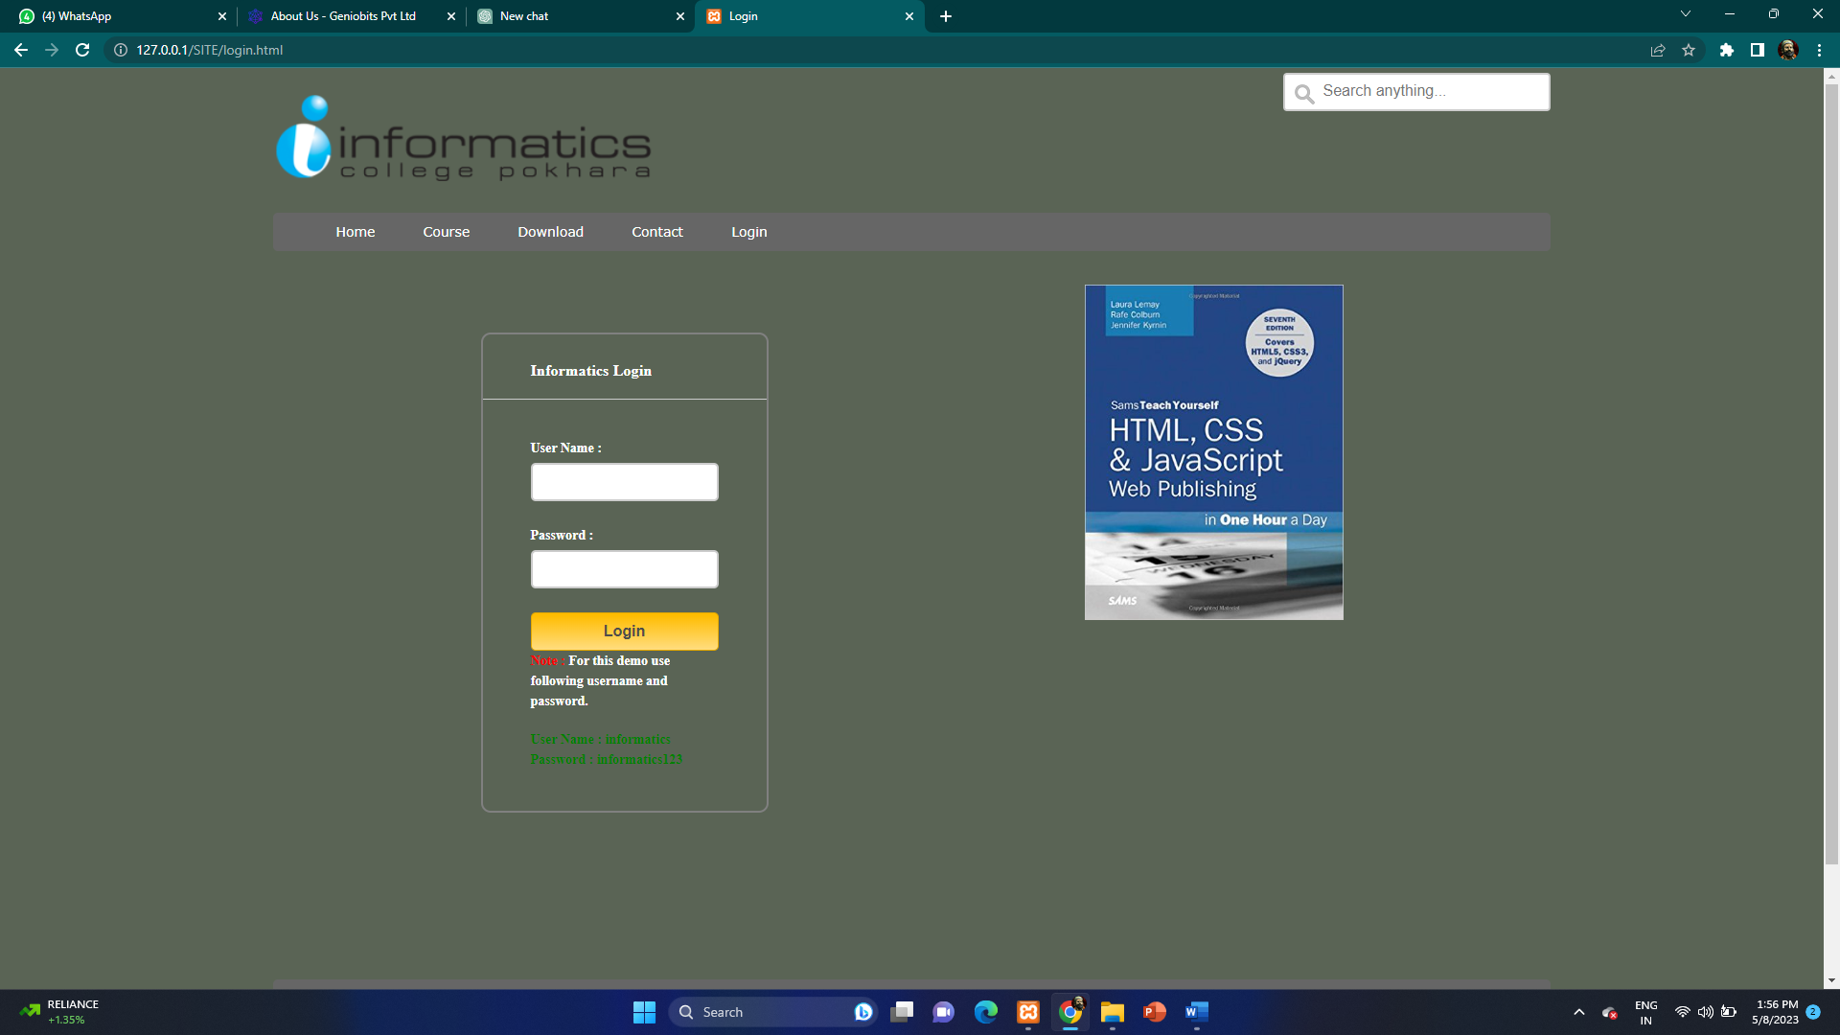

**6.2 Music Player Website**

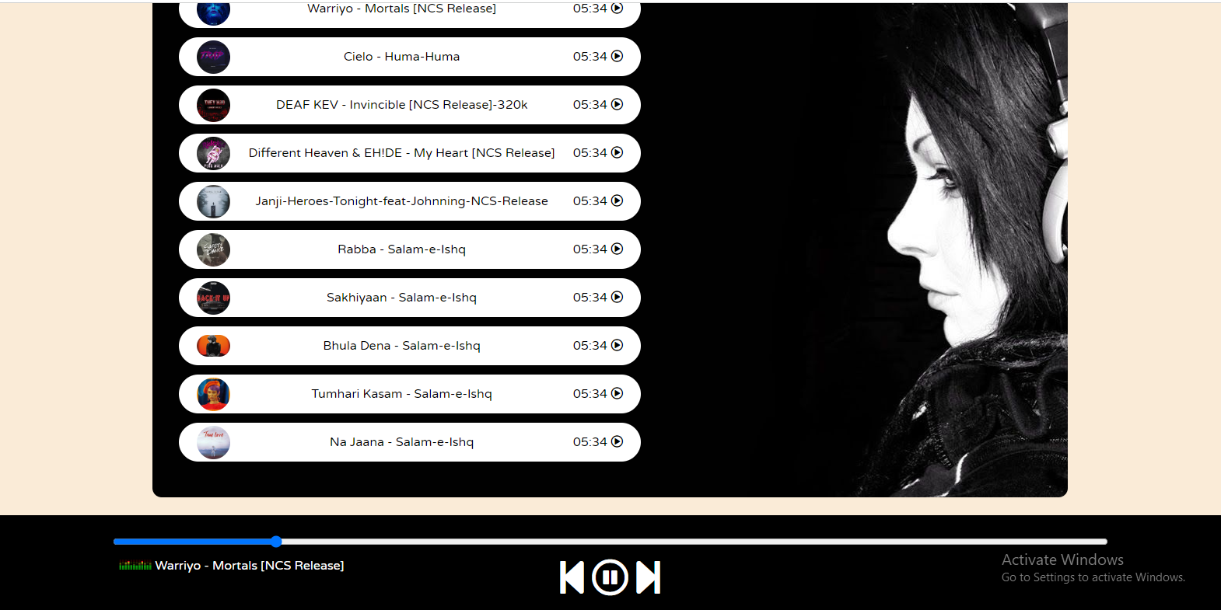

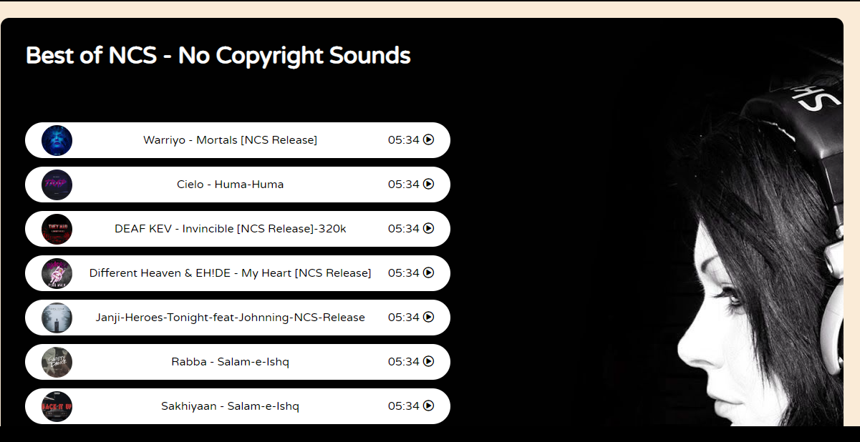

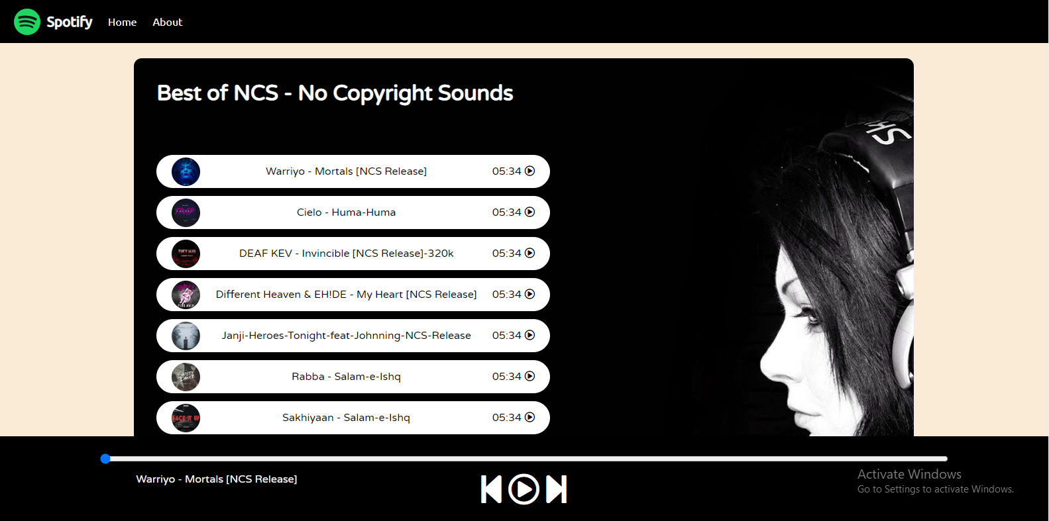

**6.2 Tic-Tac-Toe Game Website:**

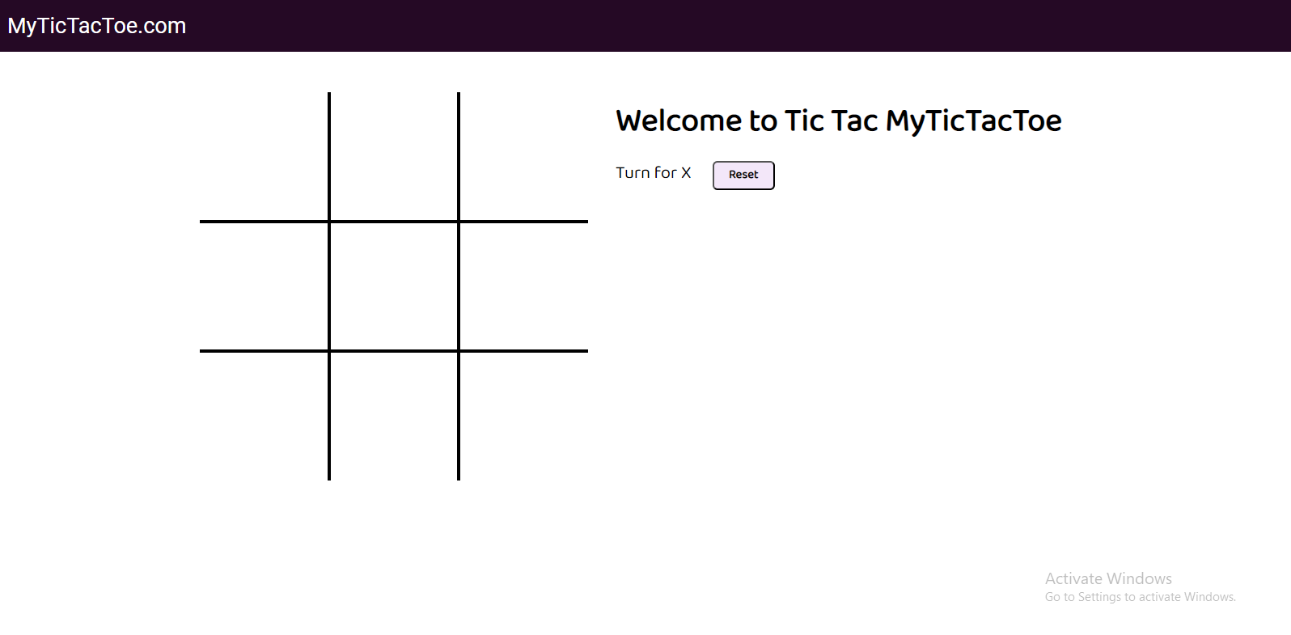

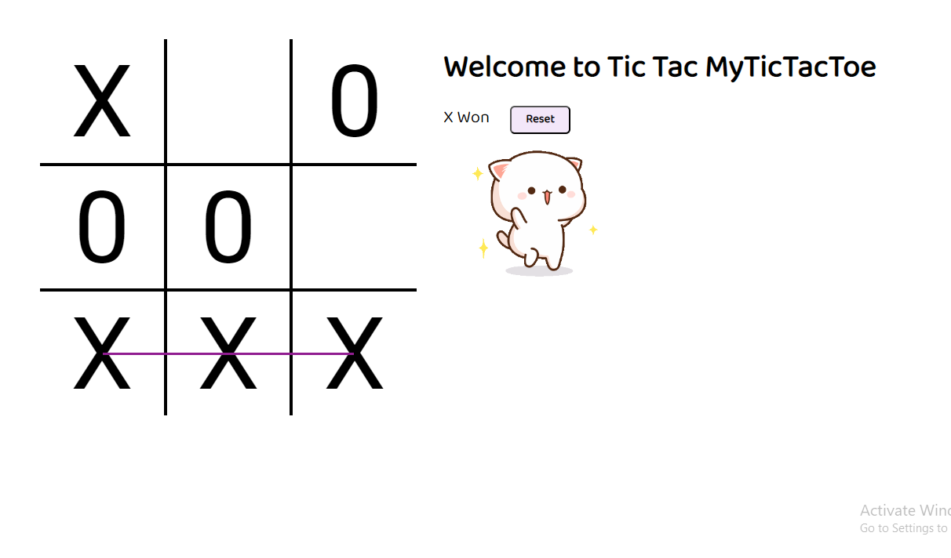

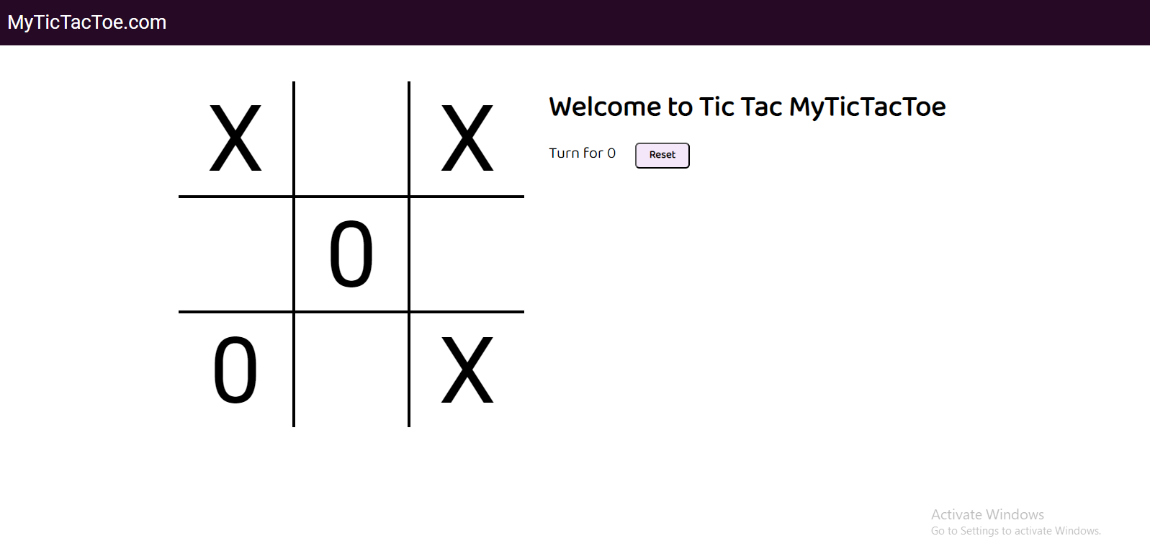

Chapter 7

**ATTENDANCE RECORD**

Chapter 8

**ACKNOWLEDGEMENT**

Internship is an integral part of engineering curriculum providing engineers with first hand and practical aspects of their studies. It gives us the knowledge about the work and circumstances existing in the company. The internship opportunity I had with **Geniobits Private Limited** was a great chance for learning and professional development. Therefore, I consider myself very lucky individual as I was provided with an opportunity to be a part of it. I am also grateful for having a chance to meet so many wonderful people and professionals who led me though this internship period.

It gives me great pleasure in completing training at **Geniobits Private Limited** and submitting the training report for the same. I am thankful to the company for the whole experience.

We are indebted to our Internship Supervisor **Prof. Dikshendra Sarpate** from Zeal college of engineering & Research. We feel it’s a pleasure to be indebted to our guide for her valuable support, advice and encouragement and we thank her for her superb and constant guidance towards this project.

We sincerely thank **Prof. Dikshendra Sarpate** Head of the Department of Computer Engineering and for all the facilities provided to us in the pursuit of this internship.

Chapter 9

**CONCLUSION**

This internship at Geniobits Private Limited, has aided me in gaining practical experience. Online internship of this kind helped me to get used to an online project atmosphere and thus prepared me to face the world of engineering in much better and confident way. I’m sure that after completing this internship I will be able to visualize the work situation in a better way.

I have also had the chance to work with a team of experienced professionals who have provided me with guidance, support, and valuable feedback on my work. This has helped me to grow both personally and professionally and has given me a better understanding of what it takes to be a successful web developer.

Overall, I am grateful for the opportunity to have completed this internship and for the knowledge and skills I have gained through this experience. I am confident that the skills I have learned will be useful in my future career as a web developer, and I look forward to applying them in my future endeavors. Finally, I would like to express my sincere thanks to [Company Name] and all the individuals who have contributed to my growth and development during my internship period

Thus, I confidently conclude that this internship was beneficial in its technical and educational aspect, the experience is bound to help me in the years to come.

Chapter 10

**REFERENCES**

[1] Mozilla Developer Network (MDN) - https://developer.mozilla.org/en-US/docs/Web

[2] W3Schools - https://www.w3schools.com/

[3] Stack Overflow - https://stackoverflow.com/

[4] GitHub - https://github.com/

[5] Codecademy - https://www.codecademy.com/

[6] CodePen - https://codepen.io/

[7] Smashing Magazine - https://www.smashingmagazine.com/

[8] A List Apart - https://alistapart.com/

[9] Google Developers - https://developers.google.com/

[10] Web Platform Docs - https://webplatform.github.io/docs/